# PagerDuty integrate/un-integrate with Slack

## Background

If you want to PagerDuty send its incidents to the required slack channel, you can just integrate PageDuty with Slack in PagerDuty

PagerDuty has provided the feature, you can integrate service/team with a slack channel

## Permission

Before integration, your "team role" must  be a manager , then you have the permission to integrate the team's service with Slack

Go to the team page, then click "Users" to check , Contact the manager to add the permission

## Integrate with Slack

1. Go to "Integrations"→"Extensions"

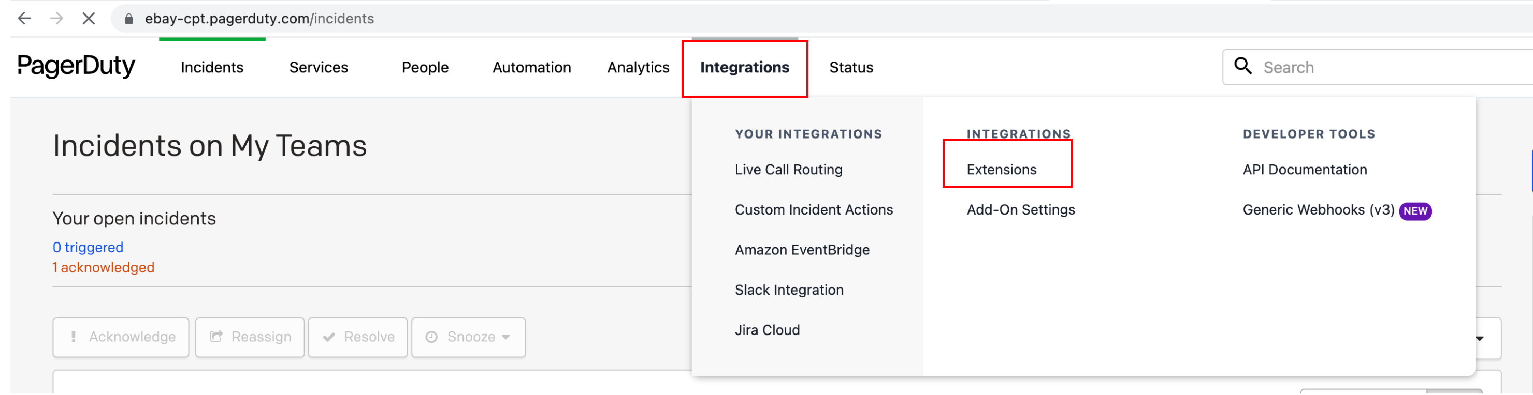

2.  Click "Slack Integration"

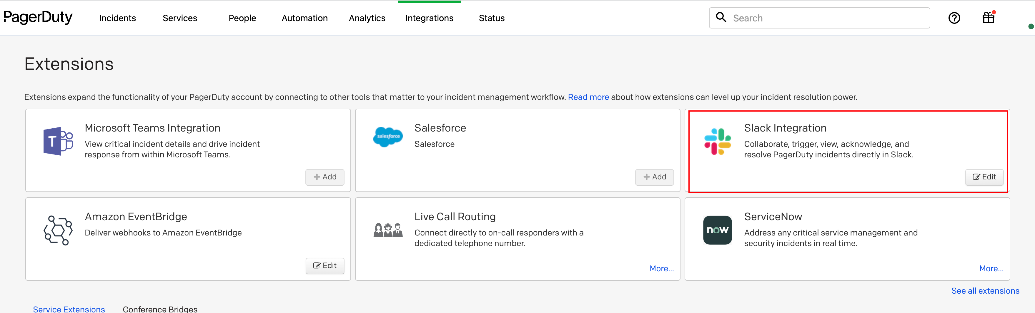

3. Click "View"

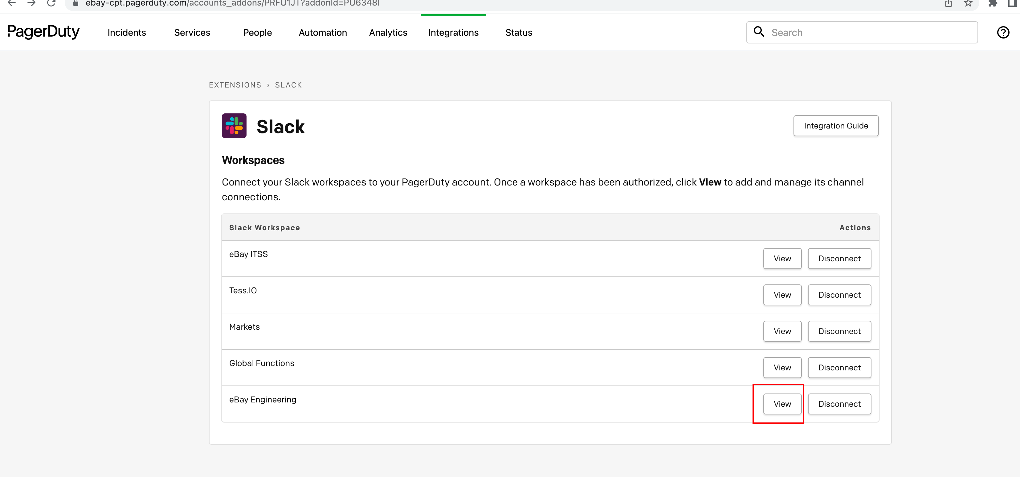

4. Click "Add connection", select the service or team, and the channel and select the updates if you only need some updates send to Slack

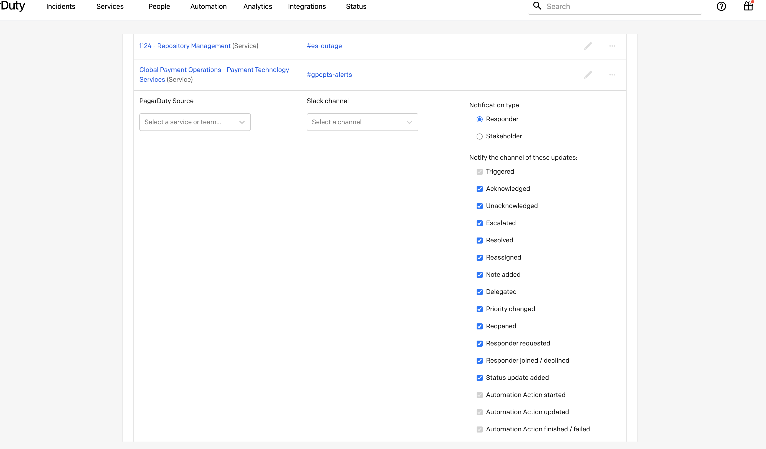

## Un-integrate with Slack

Go to the connections list page, select the service you want to un-integrate, click its settings→select "Remove connection"

